[](http://www.lca.org.au/)ALBERTON LUTHERAN PARISH

 BULLETIN

**St.Peters Alberton: Jesus the same yesterday, today & forever. Hebrews 13:8**

**Contact: Doug Heim 0412204473**

[](http://www.google.com/url?sa=i&rct=j&q=&esrc=s&source=images&cd=&cad=rja&uact=8&ved=2ahUKEwjNgJCZxsjdAhWFbN4KHafjASIQjRx6BAgBEAU&url=http://mzayat.com/clipart/manger-clip-art.html&psig=AOvVaw3pO1XOU2PApz8bvy39NfNJ&ust=1537497282405351)

**Bethlehem Woongoolba: Jesus came and lives amongst us. John 1:14**

**Contact: Trevor Zipf 0409270047**



**LORDS Pimpama: We are the Lord’s. Romans 14:8**

**Parish Contact: David Huth 0419720640**

**15th Sunday after Pentecost WELCOME 22nd Sept., 2019**

**Readings for today:** [**Jeremiah 8:18 – 9:1**](http://www.biblegateway.com/passage/?search=Jeremiah%208:18%20-%209:1&version=NIV)Jeremiah mourns for the people

[**1 Timothy 2:1-7**](http://www.biblegateway.com/passage/?search=1%20Timothy%202:1-7&version=NIV)The church is to pray for all people

[**Luke 16:1-13**](http://www.biblegateway.com/passage/?search=Luke%2016:1-13&version=NIV)The parable of the shrewd manager

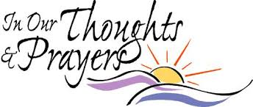

**Pray for the sick and those recovering from operations:** Chloe & Madison Gilloway; Christian Stern; Ingo Buhner; Ron & Noela Brehmer; Jessica Schwenke; Jemma Sharpley; Leona Berndt

**Pray for the world:** the people across our nations dealing with the ravages of bushfires; safety for those travelling during school holidays; Peace in the Middle East Conflict

**Pray for the church:** Michael Turner outgoing and Rick Davenport incoming District Administration at the LCAQD office; Pastors working in our parishes to spread God’s word effectively; the witness of our churches in their communities throughout Qld.



Monday: 1 Samuel 2:12-16 Saturday: Psalm 146

Tuesday: 1 Samuel 3:1-21 Sunday Luke 16:19-31

Wednesday: 1 Samuel 4:1-11

Thursday: 1 Samuel 4:12-22

Friday: 1 Samuel 7:2-17

**Some of our members and friends may remember Lindsay Rosendale’s brother, 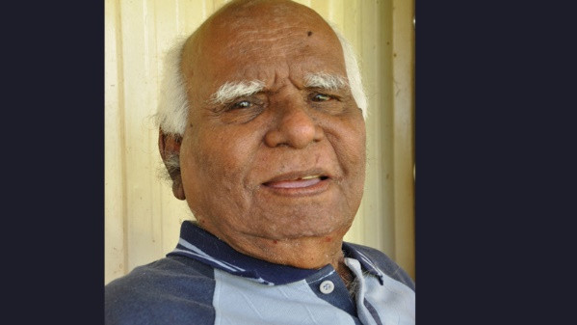Rev. Dr George Rosendale, the third Aboriginal person ordained in the Lutheran Church of Australia (LCA), died on 11 September, three weeks after the 50th anniversary of his ordination. He was 89.** As a pastor he served the communities of Coen, Cooktown, Cairns and Hope Vale, before retiring in 1992.

TheLtheran Church of Australia Queensland District gives thanks for his life :OAM DD.  Pastor Rosendale was born 14 May 1930 and was called to his eternal home on 11 September 2019.  He was ordained at Hope Vale on 24 August 1969, and retired on 1 September 1992.  Australian Lutheran College (ALC) awarded Rev. Dr. George Rosendale the Honorary Doctor of Divinity  in 2009, in appreciation of his service to the whole community in North Queensland and the Lutheran  Church of Australia.  His contribution to society was also recognised by the Australian Government, with the awarding of a  Medal of the Order of Australia on 8th of June, 1992 . We give thanks for Pastor George's life and his contribution towards the development of Indigenous  theology, reflection, and education in Australia, as a pastor and teacher of our church.

|  |  |
| --- | --- |
|  |  |

 Notes on the Readings: from LCA Resources

**JEREMIAH 8:18 - 9:1:** Jeremiah speaks God's words of grief as in prophetic vision he sees the sufferings of God's people in exile ('in a far country', or, 'from far and wide in the land'). The intensity of God's mourning matches the heart-rending, bitter despair of the people in captivity. His language is that of a parent grieving the loss of a child. To the people in exile, the mockery of their captors that the Lord cannot be present in his holy place any more torments them (the Jerusalem temple was destroyed). And yet the Lord's words establish that justice has prevailed. His people forsook him for foreign idols. Still they complain that they are left in icy winter and are not rescued. Balm of Gileal was a famous remedy for pain. There is no healing for this people, though; only their hurt and their pain. The prophet's tears and the tears of the Lord are inconsolable.

**1 TIMOTHY 2:1-7:** Paul urges the young pastor Timothy to make sure that every kind of prayer is made for all people, including those in authority. The spread of the gospel will naturally be more effective if peaceful conditions prevail. He also offers other reasons: that God wishes all people to be saved; that God is one and therefore relates to the needs of all people; that Christ was a mediator for all people; that Christ became a human being that all might be saved; and that Paul himself was an apostle to the Gentiles, and therefore to all people. God has commanded that all Christian service is upheld by prayer and has promised to hear.

**LUKE 16:1-13:** Jesus is talking to the affluent here, people who are so wrapped up in their pursuit of money and consumer material goods that they don't bother giving time to pursue their eternal welfare before it is too late. This illustrative story does not praise dubious practice in business. Jesus uses the astuteness of the dishonest manager as the quality to be emulated by Christians when addressing their spiritual needs. The children of light (disciples of Christ) are not as industrious by and large at pursuing eternal life as the children of this world are in getting ahead! The second comparison is in faithfulness of stewardship. Christ makes the point that Christian service needs to be directed single-mindedly to the Lord, not mixed also with material greed.

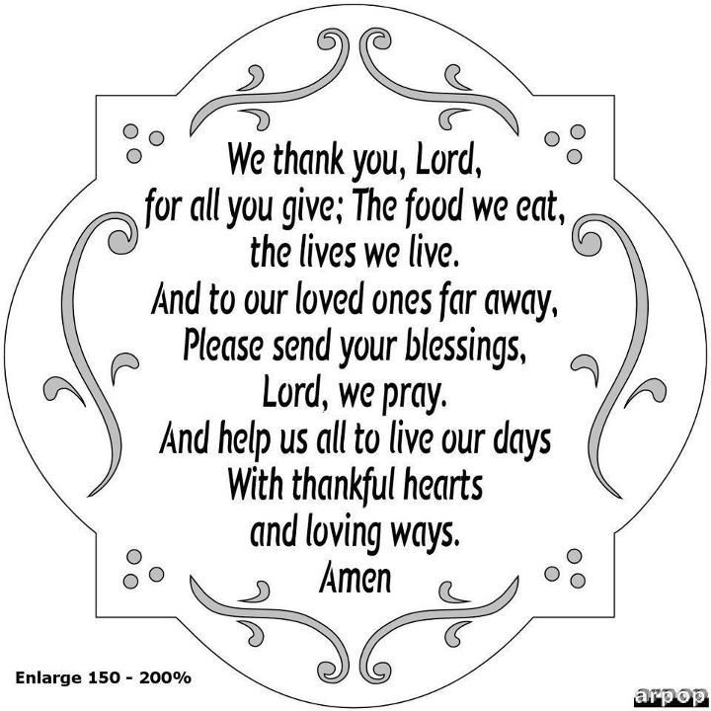

**LCAQD News & Events**

* Central Qld CLW Camp 30/9-4/10
* Promoting RI in school Sunday 13/10/19
* Replenish Women’s Retreat 18-20 Oct. Coolum $150
* Spreading the Gospel Workshops 15 & 16 Nov – Toowoomba & 22 & 23 Nov. Brisbane

**LORDS has applications open for:**

A Pastoral Care Co-ordinator for Prep-Yr6 for 3 days a week

A Full Time Primary Teacher

A Full Time Primary Teacher (Maternity Leave contract)

Application through Teachers on net.

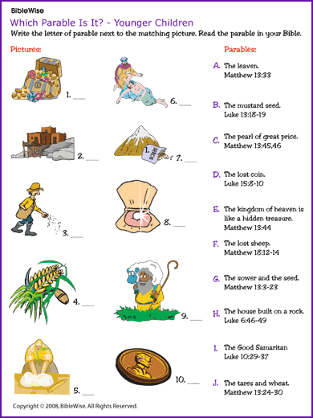 

**Wednesday: 7pm Worship Committee meets at Bethlehem**

**Thursday: 7pm Church Council meets at Bethlehem**



**NEXT SUNDAY IS A PARISH SERVICE AT BETHLEHEM AT 9:00am**

**There is NO worship service at St.Peter’s**

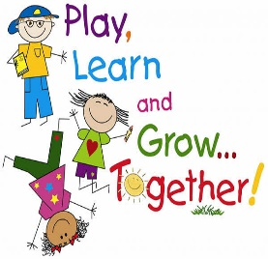**Following the service Bishop Paul Smith will conduct a Call Meeting.** Please pray for the right Pastor for our Parish & LORDS to be called. There are currently 18 Parishes in Qld alone in the calling process at the moment.

PLEASE BRING ALONG YOUR PICNIC – following the service we will proceed to Cabbage Tree Point to enjoy a family picnic together.

**FRIDAY 4th October – EVERYONE IS INVITED TO ATTEND A SPECIAL EVENT**

**AT ST.PETER’s HALL at 6:pm**

**David Fitzgerald, an inspirational speaker,** will be visiting with us to share hisexperiences after a major horse accident - how he overcame great adversity and wants to provide encouragement to those who may be facing difficulties and to not give up. Please invite your friends. Bring along a main course and dessert to share in a Pot Luck Dinner. We look forward to welcoming you on the night.

……………………………………………………..

Did you know that coming up, tomorrow, on September 23rd – we are celebrating the **International Day of Sign Language.** The Bible Society will mark the culmination of a 22 year project to translate the bible into the first language of 70% of Australia’s 50,000 deaf people. The Auslan Bible will be available in an online format. If you are in Sydney on this day at 2pm you are welcome to join the celebration. events@biblesociety.org.au

**ROSTERS for 29th September.**

**Readings:** [**Jeremiah 32:1-3a,6-15**](http://www.biblegateway.com/passage/?search=Jeremiah%2032:1-3,6-15&version=NIV)

**1 Tim.6:6-19; Luke 16:19-31**

**St.Peter’s – N/A no service**

**Bethlehem**

Reader:

Music: Kay

Morning Tea: Wendy & Cathy

Church Beautification: Wendy & Jane

Ushers: Shirley & Scott

