[](http://www.lca.org.au/)ALBERTON LUTHERAN PARISH

 BULLETIN

**St.Peters Alberton: Jesus the same yesterday, today & forever. Hebrews 13:8**

**Contact: Doug Heim 0412204473**

[](http://www.google.com/url?sa=i&rct=j&q=&esrc=s&source=images&cd=&cad=rja&uact=8&ved=2ahUKEwjNgJCZxsjdAhWFbN4KHafjASIQjRx6BAgBEAU&url=http://mzayat.com/clipart/manger-clip-art.html&psig=AOvVaw3pO1XOU2PApz8bvy39NfNJ&ust=1537497282405351)

**Bethlehem Woongoolba: Jesus came and lives amongst us. John 1:14**

**Contact: Trevor Zipf 0409270047**



**LORDS Pimpama: We are the Lord’s. Romans 14:8**

**Parish Contact: David Huth 0419720640**

**12th Sunday after Pentecost WELCOME 1st Sept., 2019**

**Readings for today**

**Jeremiah 2:4-13 OR Proverbs 25:6,7 accuses Israel of turning away/wisdom of humility**

**Hebrews 13:1-8,15,16 Obligations in community, home & church**

**Luke 14:1,7-14 Humility & hospitality**

Please continue to pray for Ingo Buhner and anyone else who you know is unwell at this time.

Please pray that each might take up his/her role in the community in a spirit of humbleness and hospitality

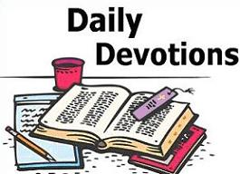Mon: Romans 11:13-24;

Tues: Romans 11:25-36

Wed: Romans 12:1-8

Thur: Romans 12:9-21

Frid: Romans 13:1-7

Sat: Psalm 1

Dear Father,

What a day!? A day to remember who has taught me, guided me and instilled wisdom in me my entire life. You have promised countless times that you love me. You have promised that you will never leave me. You even went so far as to show me how much you love me by sending your only Son. Can I ask for anything else? Of course I can, and I always do. As any good father would do, you do what you feel is right in whether or not I should get what I ask for.

I hope one day to be even half or even a quarter of the Father you've been to me. I hope that when my kids need something, I'm there for them as you have been for me. I hope that when my kids have questions, that I'm there for them as you have been for me. I hope that when they are going through good times or bad that I'm there for them, just as you have always been there for me. So I end this letter by thanking you for being my Father and by writing that I have been VERY blessed by being one of your children! Furthermore, I want to thank you for your undivided attention for me by treating me as your only child when I'm talking, even though you have countless children. Happy Father's Day! Signed your precious child

Notes on the Readings from the LCA website:

JEREMIAH 2:4-13: Whoever wronged whom, that Israel even far back in its history forsook the Lord? This was the Lord who rescued them from Egyptian slavery to establish them in the land flowing with milk and honey! Even their priests and kings joined them in transferring loyalty to Baal. God could accuse them of treachery never even shown by the heathen towards their non-existent gods. Tragically there seemed to be no witness left but the heavens themselves to the people's shocking preference to dig their own personally polluted cisterns in rejection of the constant flowing living waters from the Lord.

PROVERBS 25:6,7: Arrogance is at any time unwarranted. It is more fitting to compare oneself with those who are wiser, greater or more accomplished than those we consider to be our inferior. An unsolicited elevation is infinitely preferable to one's pride having been set before a fall, where one is humiliated in the presence of the same 'inferior'.

HEBREWS 13:1-8,15,16: In this chapter the writer rounds off the letter with appeals directed towards fulfilling specific injunctions of Christ for worthy living. This is in keeping with the Lord's comforting promise never to leave nor forsake his disciples. His unchanging nature, yesterday, today and forever, provides double assurance. To Christ's own, true sacrifices consist of thanksgiving, confession of the truth and sharing in love with the needy.

LUKE 14:1,7-14: Jesus' hosts were watching him malevolently. This particular teaching was not simply to impart good social advice as in Proverbs 25:6,7. Luke tells us this was a parable. It therefore illustrates something significant about the kingdom of God. God does not have special regard for those who ambitiously place themselves in positions of importance. God rather humbles the proud and raises up the humble. Neither should invitations and favours be bestowed in the hope of personal gain as the outcome. God will reward whatever freehearted service is humbly given without expectation of gain, perhaps not now but most certainly in the resurrection.

Today Jesus teaches us a very important lesson about how to live. He was with a group of people who were about to sit down at a table for a special meal. We can imagine that perhaps some of the seats were special seats and other seats were ordinary old seats. Everyone wanted to sit on the ‘new soft’ special seats and no one wanted to sit on the ordinary ‘old’ seats. I wonder, which seat you would have chosen? Jesus saw what was happening and told them a story about some people who quickly went and sat at the special seats but soon after they were told to move to the ordinary old seats. How embarrassing it would be to be told to swap seats! It is better to let others sit at the special seats first. Sometimes in life we like to think that we are so important that we deserve the best of everything, even the best seats at the table. But Jesus wants us to stop racing to get the best of everything for ourselves. Jesus wants us to be like him, to be humble, and welcome others to the best seats. That’s what Jesus does for us. He was humble, he is saving us the best seats with God forever! PRAYER Lord Jesus, teach us to be humble just like you. Help us to welcome all people in your name. Amen.

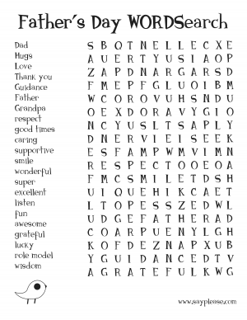

Monday:10am Cuppa & Chat at Bethlehem

Wednesday: 9:30 am “Come Travelling along with Me”

Cleveland Lutheran Church

SUNDAY SERVICES: 8am Bethlehem & 9:30 St.Peter’s

**Do you know about Luminate:** This is a year of discipleship for students who have finished year 12 and want to experience something great before starting a new pathway in life. It is a ministry of Lutheran Youth of Qld providing a year of transformative personal growth for young people. It is both an individual and group journey in learning more about our identity in Christ and how to live that out with others. The best learnings are those practiced and experienced in community, therefore, time is taken to intentionally foster relationships. Participants spend part of their 2 days together each week checking in with each other, praying for each other, being challenged by each other and being encouraged by each other in their new knowledge and experiences within the program, study and life. Luminate provides opportunities to take the learning from your head into your heart. Rebecca Rokesky is considering adventuring into this next year. Please encourage and support her wherever possible.

**September 13th: Back to the Country at LORDS**

[](https://aus.edutest.com.au/D/?t=3972Y681)**Our whole school community is invited to the FOLS Bush Dance. The night will include live entertainment, sausage sizzle and ice cream van! Great family entertainment. We hope all our students from Kindy to Year 12 will come along with family and friends and enjoy a great night out. See flyer for more details.**

**ROSTERS for 8th September, 2019**

**Readings: Jer.18:1-11or Deut.30:15-20; Philemon 1-21; Luke 14:25-33**

**St.Peter’s**

Reader: Ian

Music: Linda

Morning tea: N/A

Church Beautification: Helen

Ushers:

**Bethlehem**

Reader: Joy & Sophee

Music: Romi

Morning Tea: Christine & Jane

Church Beautification:

Ushers: Shirley & Scott

**Apply now for Prep and Year 7- 2020 intake!**

**Principal interviews are already under way.**

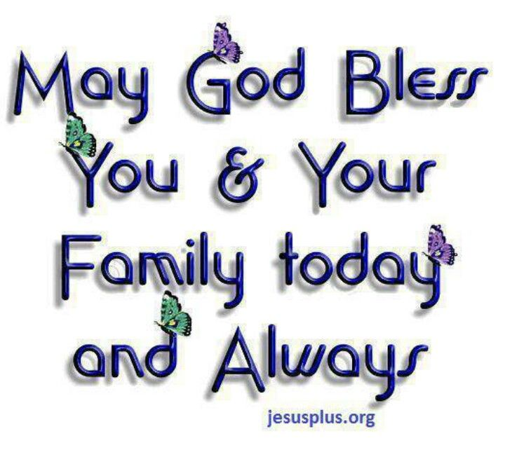

**Parish Call committee met on Tuesday night and will be interviewing three prospective pastors during the next week. Please keep this process covered in prayer. We have an awesome God who will supply all our needs. Praise the Lord!**