[](http://www.lca.org.au/)ALBERTON LUTHERAN PARISH

 BULLETIN

**St.Peters Alberton: Jesus the same yesterday, today & forever. Hebrews 13:8**

**Contact: Doug Heim 0412204473**

[](http://www.google.com/url?sa=i&rct=j&q=&esrc=s&source=images&cd=&cad=rja&uact=8&ved=2ahUKEwjNgJCZxsjdAhWFbN4KHafjASIQjRx6BAgBEAU&url=http://mzayat.com/clipart/manger-clip-art.html&psig=AOvVaw3pO1XOU2PApz8bvy39NfNJ&ust=1537497282405351)

**Bethlehem Woongoolba: Jesus came and lives amongst us. John 1:14**

**Contact: Trevor Zipf 0409270047**



**LORDS Pimpama: We are the Lord’s. Romans 14:8**

**Parish Contact: David Huth 0419720640**

**9th Sunday after Pentecost WELCOME 11th August, 2019**

Welcome to everyone worshipping with us today. We are pleased that you have joined us. Our prayer is that the holy Spirit would enlighten and empower all of us through today’s message.

**Today’s Bible Readings:** Isaiah 1:1. 10-20 God talks to his people OR Genesis 15:1-6 Abraham is justified by faith in God’s promise

Psalm 50:1-8,22,23 OR Psalm 33:12-22 Hebrews 11:1-3,8-16 Living in faith in God’s presence

Luke 12:32-40 Be ready for Christ’s return. 

Reflection on Faith



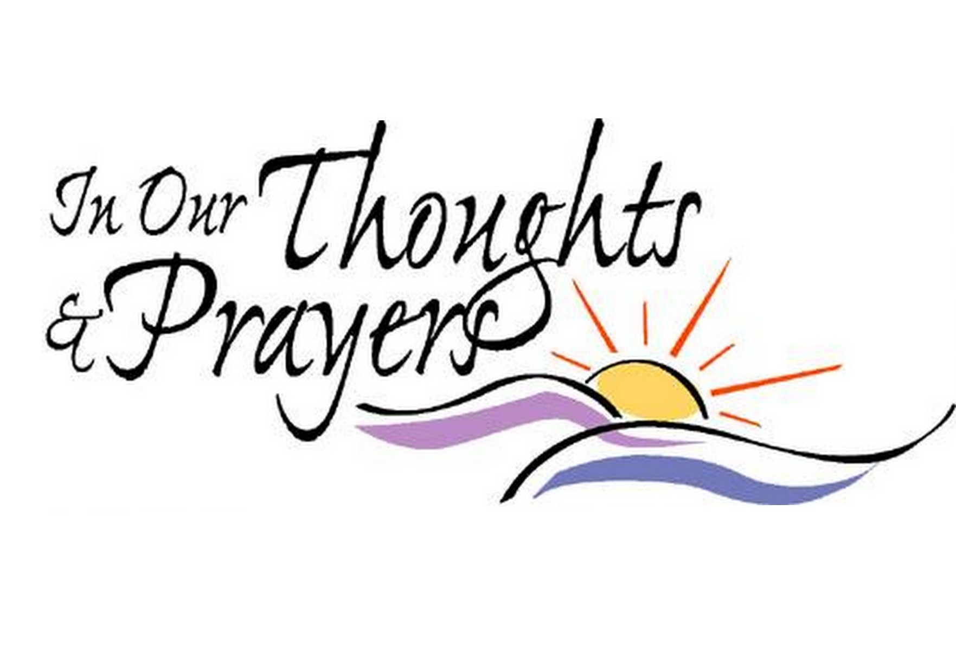

Ingo Buhner; Alec Keith & the Keith family

Hammel Family; The sick & their families

**For Your Devotions this week**

Monday Romans 5:12-21

Tuesday Romans 6:1-11

Wednesday Romans 6:12-23

Thursday Romans 7:1-12

Friday Romans 7:13-25

Saturday Psalm 82

Sunday Luke 12:49-56

**Notes on Today’s Readings**

**Isaiah 1:1,10-20:** The countryside of Judah lay devastated by the Assyrian army, yet the nation seemed to be asking for more retribution from the hand of God. The reference to Sodom and Gomorrah reduces Jerusalem and Judah to a level of moral revulsion. While it was obvious from the detailed list of rituals that people were in fact involved in the temple worship, yet Isaiah proclaims that both offerings and the offerers were rejected. The Lord found them an abomination because of their moral behaviour and the absence of true social concern for the poor and helpless. In that light, Isaiah's appeal to the nation to return to the Lord in true repentance is most moving. If scarlet sin can be made as white as snow, then there is certain assurance of forgiveness. However, repentant obedience receives grace, while rebellion invites the further retribution of God.

**Genesis 15:1-6:** This is the fifth revelation given by God to Abram concerning future blessing to the world through an heir. In view of Abram's and Sarai's advanced age and their trust that the promise would come true, they had tried different strategies to 'make it happen' according to their own understanding. The Lord had borne with these emergent problems but now he provided new courses to support Abram in his faith. He showed Abram the stars with the promise of equally numerous descendants, not just one! With this assurance Abram simply believed in tranquil obedience. We are told that 'God counted (reckoned) it to him as righteousness'. That is an act purely on God's part, ie to count Abram's obedient faith as 'righteousness', not an attainment reached by Abram himself.

**Hebrews 11:1-3; 8-16:** Faith deals with things future and invisible. Just as the whole creation came into existence from nothing by the power of the divine word, just so, faith is sure of the fulfilment of God's promises for the future and the reality of things which we cannot see. Abraham is cited as a supreme example for his trust in a future unfolding both physical and spiritual blessings that were absolute impossibilities from a human perspective. God's gift of the heavenly homeland came to those believers of old who maintained their trust, just as it will come to us who live in the assurance of things hoped for with the conviction of things not seen.

**Luke 12:32-40:** The Lord here consoles his followers with the thought that though they are a small group in a large and threatening hostile world, they are still his little flock to whom the Father will give the kingdom. Yet their faith will inevitably be tested. Therefore material possessions should be kept in their place and shared when the need presents itself, for heavenly treasure lasts eternally. The return of the Lord also tests believers' faith. Because of its delay, the temptation is to grow spiritually lazy. The obedience of constant readiness goes with a vital and live faith in the reality of the future heavenly life that we cannot as yet see and the fulfilment of the promises for which we hope. The Lord has already saved his servants through his redemption from sin. Let us be eagerly waiting when he knocks.

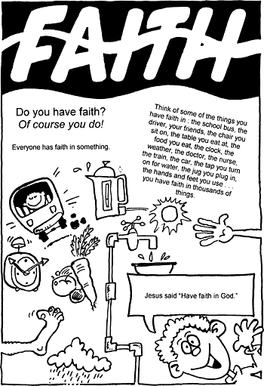

**MONDAY:**  **Everyone is welcome to attend “A CROP OF MEMORIES” 9:30am at St.Peter’s Alberton. $7 entry donation**

**Men are also welcome to come along**!

**SATURDAY: Buttons, Bows & Blessings**

**8:00-9:30am On the Edge Café, George St. Beenleigh. Please bring along a souvenir for ‘show & tell’ for our theme “Come, travelling along with me’.**

**SPECIAL NOTE** : Bethlehem Church Council has been shifted to Wednesday 25th August.

**NEXT SUNDAY**

8:00am St.Peter’s Worship & 9:30am Bethlehem Worship

3:00pm “Tink Tank” – hosted at Bethlehem – Please come along and contribute your ideas for future planning for Alberton Parish & the LORDS community.

On Tuesday night the Parish Call Committee met to discuss our options going forward regarding calling a new pastor for our Parish & LORDS. We are currently making enquiries throughout Australia for Pastors who may be interested in serving us. We ask that each and everyone of you keep this process blanketed in your prayers so that the Holy Spirit will lead us to the right person for our community.



**Spread the LOVE:** BSGCZ ladies have started an initiative to spread the love to our country members and friends who are still doing it tough after the drought. Pastor Mark Hampel has agreed to ‘play Santa Claus’ and deliver our gifts to families in country Qld before Christmas. Anyone who would like to donate a wrapped Christmas gift for a man/lady/child it would be greatly appreciated. You just need to label the gift accordingly and if a child include the age. A handwritten note of encouragement would also be appreciated. Gifts can be left in the foyer of either church.

**ROSTERS for August 18th**

**Readings: Isaiah 5:1-7 OR Jer.23:23-29; Hebrews 11:29-12:2; Luke12:49-56**

**St.Peter’s**

Reader: Yvonne Morning tea: Group 1 Church

Beautification: Phylis & Yvonne

**Bethlehem**

Reader: Mike Music: Kay Morning Tea: Joy & Shay

Church Beautification: Kay & Di

Ushers: Trevor & Russ