[](http://www.lca.org.au/)ALBERTON LUTHERAN PARISH

 BULLETIN

**St.Peters Alberton: Jesus the same yesterday, today & forever. Hebrews 13:8**

**Contact: Doug Heim 0412204473**

[](http://www.google.com/url?sa=i&rct=j&q=&esrc=s&source=images&cd=&cad=rja&uact=8&ved=2ahUKEwjNgJCZxsjdAhWFbN4KHafjASIQjRx6BAgBEAU&url=http://mzayat.com/clipart/manger-clip-art.html&psig=AOvVaw3pO1XOU2PApz8bvy39NfNJ&ust=1537497282405351)

**Bethlehem Woongoolba: Jesus came and lives amongst us. John 1:14**

**Contact: Trevor Zipf 0409270047**



**LORDS Pimpama: We are the Lord’s. Romans 14:8**

**Parish Contact: David Huth 0419720640**

**8th Sunday after Pentecost WELCOME 4th August, 2019**

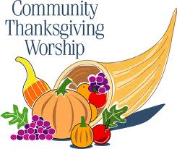

**Special Readings for this service today:-**

**Deuteronomy 28:1-9**

**Romans 13:1-8**

**Mark 12:13-17**

|  |  |  |
| --- | --- | --- |
|  | Daily Bible Reading | Special Prayer Points this week |
| **Monday** | **Romans 3:9-20** | **For healing: Ingo Buhner & those suffering illnesses** |
| **Tuesday** | **Romans 3:21-31** | **Thankfulness for our community helpers in all areas** |
| **Wednesday** | **Romans 4:1-12** | **To offer our hears thankfully for God’s enduring love in our life** |
| **Thursday** | **Romans 4:13-25** | **For God to forgive our faulty memory & bless us in His name** |
| **Friday** | **Romans 25:1-11** | **Pray for each member of your family by name** |
| **Saturday** | **Psalm 33** | **Pray for specific needs of 5 friends by name** |
| **Sunday** | **Luke 12:32-40** | **Pray for one special person for a specific need** |

*Bible Readings are taken from the Lutheran Media Ministry: Communicating Christ*

**Scripture Reading :** Give thanks to the LORD, for he is good. [Psalm 136:1](https://bibles.org/eng-NIV/Ps/136/1) by J.Dekker

How can you, your family, and your community thank God for his enduring love?

I remember hearing this psalm as a child, and it seemed to go on forever. As I grew older, though, I realized the writer of [Psalm 136](https://bibles.org/eng-NIV/Ps/136/) wished to show readers repeatedly that God’s love endures forever. Read and re-read this psalm as a truly attentive child of God who is daily growing to know God better. Practice by carefully reading aloud the first part of every verse, reflecting on every phrase. The verses of [Psalm 136](https://bibles.org/eng-NIV/Ps/136/) recall concrete examples from history in which the Lord showed his enduring love.

If you wish, look up the full report of each of those examples in the books of Genesis, Exodus, Joshua, and Judges. Then try to identify personally with as many of the instances of the Lord’s enduring love that the verses suggest to you. Can you identify any of the Lord’s great wonders? that awed you? That comforted you? Can you name a time in your life when the Lord led you through the desert?

As you mull over each verse and each example of God’s love, repeat the psalm’s refrain again and again. What do you think is the most fitting response to God for his enduring love in all its instances?

Thankfulness Quotes for Reflection:

* When you rise in the morning give thanks for the light, for your life, for your strength. Give thanks for your food and for the joy of living. If you see no reason to give thanks, the fault lies in yourself.
* Be thankful for what you have – you’ll wind up having more. If you concentrate on what you don’t have, you will never, ever have enough.
* Be true to yourself, help others, make each day your masterpiece, make friendships a fine art, drink deeply from good books – especially the bible, build a shelter against a rainy day, give thanks for your blessings and pray for guidance every day.
* In everyone’s life at some time, that inner fire goes out. We should be thankful for the person that reignites the flame and rekindle the inner spirit.
* Gratitude unlocks the fulness of life. It turns what we have into enough and more. It turns denial into acceptance, chaos into order, confusion to clarity. It can turn a meal into a feast, a house into a home and a stranger into a friend.
* Talent is God given – be humble. Fame is man given – be thankful. Conceit is self given – be careful.
* God has forgiven me, for which I am thankful, which has allowed me to forgive myself and move forward one day at a time.
* Make it a habit to tell people ‘Thankyou!’ To express your appreciation sincerely without the expectation of something in return. Truly appreciate those around you and soon you will find more around you. Truly appreciate life and thank God for it.
* I am even thankful for the negative things that have made me a stronger and better person.
* A prayer of appreciation acknowledges the presence of good wherever you shine the light of your thankful thoughts.
* Some people are always grumbling that roses have thorns, I am grateful that thorns have roses.
* Thankyou expresses extreme gratitude, humility and understanding.
* Gratitude makes sense of our past, brings peace for today and creates a vision for the future. It is the fairest blossom that springs from the soul. Feeling gratitude and not expressing it is like wrapping a present and not giving it.
* The trick is to be grateful when your mood is high and graceful when it is low.
* I give all glory to God. It’s a kind of win-win situation. The glory goes up to him and the blessings fall down on me.
* Thank God for all the little ups and downs of life that make life worth living. I am grateful for every moment of every day no matter what form it takes.
* I am thankful that God has given me a supportive spouse, family and friends with whom I can feel comfortable and blessed.
* The hardest arithmetic to master is that of counting our blessings.
* I am thankful that I have the freedom to start and finish my day in prayer with a loving God who is always there for me and understands me in every way.



**THIS WEEK IN OUR PARISH**

Monday – 10am Cuppa & Chat at Bethlehem

Wednesday – St.Peter’s Ladies join with Bethesda Ladies for morning tea at the Lagoon Nursery

Sunday Worship– 8am Bethlehem & 9:30 St.Peter’s

**Upcoming Events**

Monday 12th August : **St.Peter’s Ladies Annual Brunch**: “A Crop of Memories” 9:30 start. All members and friends are very welcome. $7 donation.

Thursday 15th 7pm: Bethlehem Church Council

Saturday 17th August 8am-9:30am: **Buttons, Bows & Blessings** at On the Edge Café in George St.Beenleigh (opposite McDonalds) Theme: ‘Come, Travelling along with me’. Please bring along a souvenir from your travels to ‘show and tell’. Please RSVP to Lyn by Sunday 11th - 0448260380

**Spread the LOVE:** BSGCZ ladies have started an initiative to spread the love to our country members and friends who are still doing it tough after the drought. Pastor Mark Hampel has agreed to ‘play Santa Claus’ and deliver our gifts to families in country Qld before Christmas. Anyone who would like to donate a wrapped Christmas gift for a man/lady/child it would be greatly appreciated. You just need to label the gift accordingly and if a child include the age. A handwritten note of encouragement would also be appreciated. Gifts can be left in the foyer of either church.

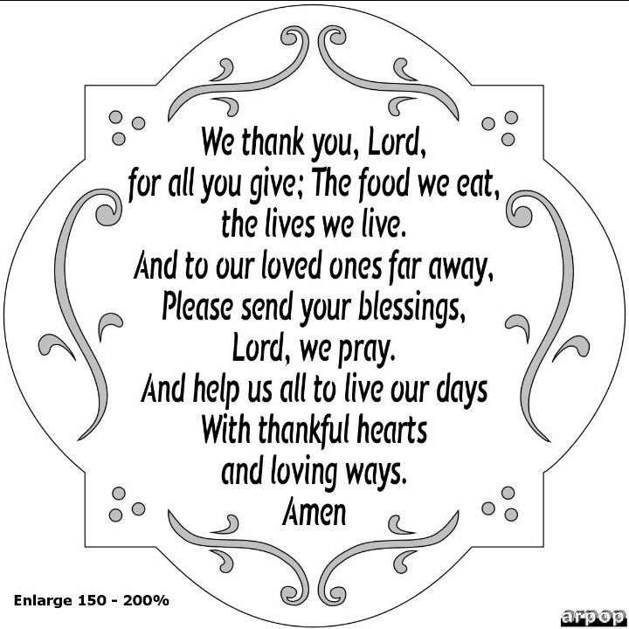

**NEXT SUNDAY ROSTERS – 11th August**

**Readings: Isaiah 1:1,10-20; Hebrews11:1-3,8-16; Luke 12:32-40**

**St.Peter’s**

Reader: Robyn Berndt

Music:

Morning tea: N/A

Church Beautification: Phylis & Yvonne

**Bethlehem**

Reader: Jodie

Music: Romi

Morning Tea: Shirley & Melissa

Church Beautification: Yvonne & Joy

Ushers: Trevor & Russ